AutoSAP HBSM Error Queue Monitoring
Solution Manager signatures signify that approvers have read, understood, and agrees with the content of this document.
Name | Job Title and Role
Erry Lavakumar | The author is signing to confirm that this document has been prepared in accordance with an approved document management process, that content is consistent with the deliverable definition found in Specify System, that relevant input from any contributory authors has been included and that an appropriate review / editing process has been conducted.
Erry Lavakumar  Nikhil Chalikwar  Akoju Sharanya | The Developer (selected by the Project Manager as responsible for the design of the system) is signing to confirm that the Design Specification is fit for purpose, that it will deliver a computer system that satisfies the System Requirements and that it will be used for the development or configuration of the computer system

Table of Contents
1 Introduction 3
2 Definition/Acronyms 3
3 General Statement of Design 3
3.1 Assumptions 3
4 References 3
5 Platform Architecture and Environment 3
6 Software Architecture 4
6.1 Generic Solution Details 5
7 System Operation Specification 8
8 Data 8
9 Security 8
10 Revision History 8
11 Appendices 8
11 Appendix-Program Logic 9

Introduction
The system will log in to the SBP and WMP systems to monitor the Error Queues in SMQ2 T-Code mainly focusing on Queue names that starts with 'CSRIXSBPI', 'CSAMPLE-BIDR', 'DL', 'ZRO', 'WMTH', 'WMD', 'EWMMEWMGOODSMVT', 'ZECC_FINDINGS', 'ZMNF','POFS'. It will send a monitoring report daily twice. This document describes the automation process of HBSM Error Queue Monitoring.

Definition/Acronyms
Item | Definition
API | Application Programme Interface
SAP | Systems Applications and Products

General Statement of Design
Design methodology/principles | This task is developed to overcome the manual effort and time spent on routine activity. The scripts are developed for end-end execution of Automation process of HBSM Error Queue Monitoring.  Automation script will login to SBP and WMP systems of SAP to check the T-code SMQ2 and sends monitoring mail for every 12 hrs along with the evidence.
Tools + version | Python 3.6, Pandas, SAP GUI 760, wincom32 API, SMTP Mail.
Programming standards | GSK Programming Standards.

Assumptions
Assuming the T- code SMQ2 is working fine.

References
None

Platform Architecture and Environment
Python 3.6

Software Architecture
Element ID | Developed Software Unit name | ID | Programming Language(s) | Description of Purpose
DS/HBSM_EQ_Monitoring/0001 | Program | autosaphbsm.py | Python | This is the main file which imports all the required neighboring python files and arrange them in a sequence to perform required action.
DS/HBSM_EQ_Monitoring /0002 | Program | cc.py | Python | This file reads the credentials to login to the SAP system
DS/HBSM_EQ_Monitoring /0003 | Program | logon.py | Python | This file will login into SAP System through SAP GUI Logon Pad.
DS/HBSM_EQ_Monitoring/0004 | Program | Smq2.py | Python | Performs smq2 T-code to get the error queues and extract/capture the evidence.
DS/HBSM_EQ_Monitoring/0005 | Program | newsqlite.py | Python | Used to store and retrieve the Error queue data into a local SQLite database.
DS/HBSM_EQ_Monitoring/0006 | Program | sender.py | Python | Sends mail to the required recipients with summary report in mail body and all the evidence in attachments.

Generic Solution Details
Authorisations
No Authorisations checks implemented as Authorisations are derived from user.
Message Class and Messages:
NA
Manual Process:
SYSTEM: SBP & WMP
The process is same for both the systems, hence login respective systems and follow the below steps.
Step1: Enter the T-Code /nsmq2 and execute to get the below screen.
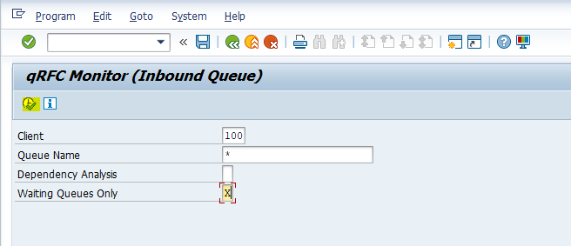

Step2: Fill the above mentioned values in the respective fields and click on execute button to get the below screen:
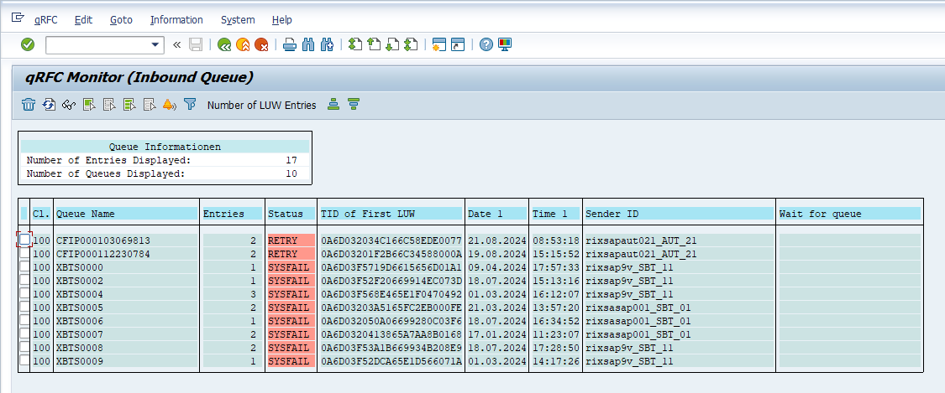
Step3: Check for Queue names that starts with any of the below list:
'CSRIXSBPI', 'CSAMPLE-BIDR', 'DL', 'ZRO', 'WMTH', 'WMD', 'EWMMEWMGOODSMVT', 'ZECC_FINDINGS', 'ZMNF','POFS'
If not found, send a Green Status Mail. Else double click on the Queue:
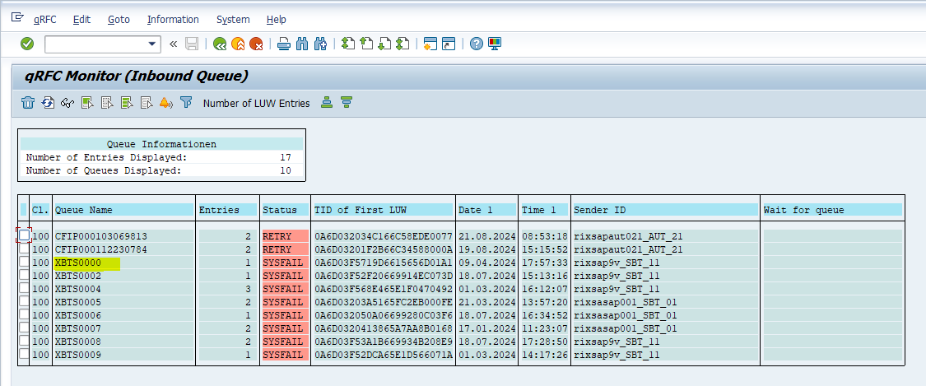

Step4: Again click on the Queue name in next screen:
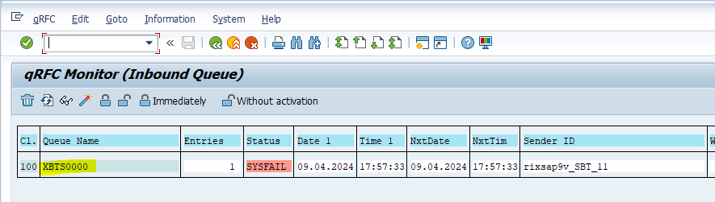

Step5: Now double click on the Status Text filed:
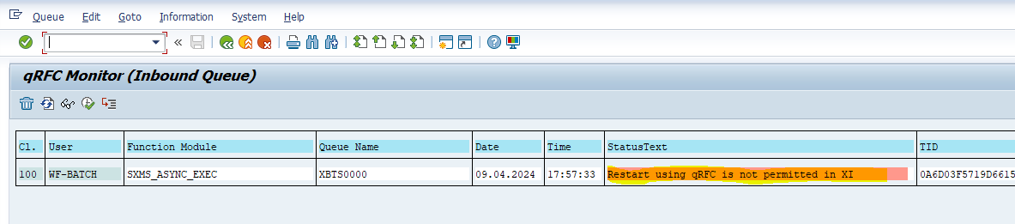

Step6: Take the screenshot of the current screen:
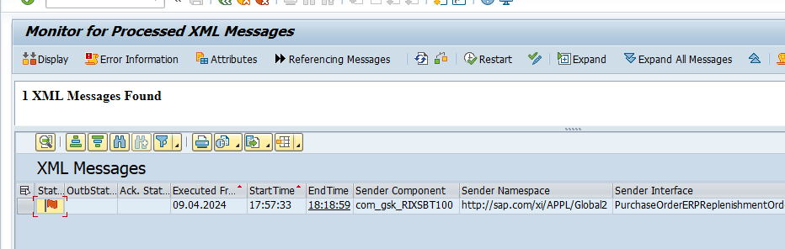

Input Format
NA
Output Format
NA
Output Medium
Print
Screen Summary
NA
Business Logic:
For detailed specification of the development please refer to Appendix – Program Logic
Run Mode
Foreground

System Operation Specification
NA

Data
NA

Security
NA

Revision History
Version | Source |  | Reason For Revision
Version | Deployment | BAU | Reason For Revision
1.0 | August-2024. | NA | This is the first issue of the document and initial version created for AutoSAP_001.

Appendices

Appendix – Selection Screen Definitions
NA

Appendix – Testing Objective
- Every day the HBSM Error Queue Monitoring is done by logging into SAP.
- This process involves checking the transaction SMQ2.
- At the end of monitoring a report is prepared and an email notification is sent to HBSM Team.
Appendix – Screen Layout Definition
NA

Appendix – Program Logic
Element ID | Logic Description
Autosap_HBSM Error Queue Monitoring | Step 1:  - Log in to the SBP and WMP system.  - Enter the T-Code /nSMQ2 and execute.  Step 2:  - Fill the client value as ‘100’ and Queue Name as ‘*’ and click on execute.  Step 3:  - Check for Queue names that starts with any of the below list:  - 'CSRIXSBPI', 'CSAMPLE-BIDR', 'DL', 'ZRO', 'WMTH', 'WMD', 'EWMMEWMGOODSMVT', 'ZECC_FINDINGS', 'ZMNF','POFS'  - If not found, send a Green Status Mail. Else double click on the Queue.  Step 4:  - Again click on the Queue name in next screen.  Step 5:  - Now double click on the Status Text filed  Step 6:  - Take the Screenshot of the screen.

Appendix – Output Layout Details
NA

Appendix – Sample Output Formats
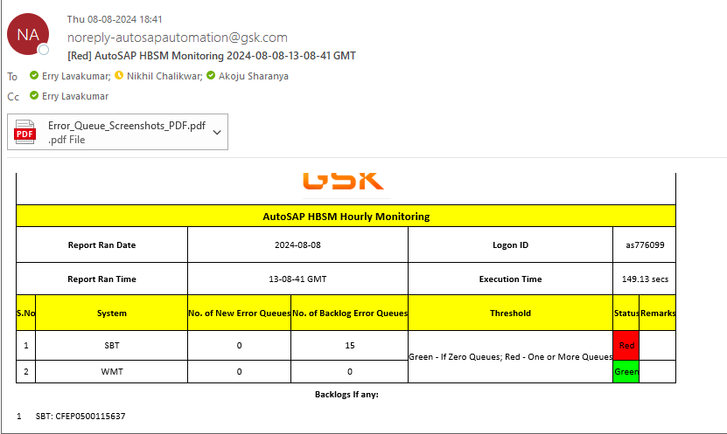

Appendix – Function Module Detail
NA
Appendix – Further Solution-specific sections
NA
Appendix – IDOC Detail
NA
Appendix – Data Dictionary Objects
NA
Appendix – Portal / Java Developments
NA
Appendix – Data
NA

